1. **Create a class named 'Member' having the following members :**

**Data members**

**1 - Name**

**2 - Age**

**3 - Phone number**

**4 - Address**

**5 - Salary**

**It also has a method named 'printSalary' which prints the salary of the members.**

**Two classes 'Employee' and 'Manager' inherit the 'Member' class. The 'Employee' and 'Manager' classes have data members 'specialization' and 'department' respectively. Now, assign name, age, phone number, address and salary to an employee and a manager by making an object of both of these classes and print the same.**

**→**

import java.util.Scanner;

class Member{

String name, number, address;

int age;

double salary;

public void printSalary(){

System.out.println("\nSalary : "+salary);

}

}

class Employee extends Member{

String specialization;

public void spec(){

System.out.println("\nSpecialization : "+specialization);

}

}

class Manager extends Member{

String department;

public void dept(){

System.out.println("\nDepartment : "+department);

}

}

public class Ans{

public static void main(String[] args){

Scanner sc = new Scanner(System.in);

Employee e = new Employee();

System.out.print("Enter employee's name : ");

e.name = sc.next();

System.out.print("Enter employee's age : ");

e.age = sc.nextInt();

System.out.print("Enter employee's number : ");

e.number = sc.next();

System.out.print("Enter employee's address : ");

e.address = sc.next();

System.out.print("Enter employee's salary : ");

e.salary = sc.nextDouble();

System.out.print("Enter employee's specialization : ");

e.specialization = sc.next();

Manager m = new Manager();

System.out.print("Enter employee's department : ");

m.department = sc.next();

System.out.print("Name : "+e.name);

System.out.print("\nAge : "+e.age);

System.out.print("\nNumber : "+e.number);

System.out.print("\nAddress : "+e.address);

e.printSalary();

e.spec();

m.dept();

}

}

**OUTPUT :**

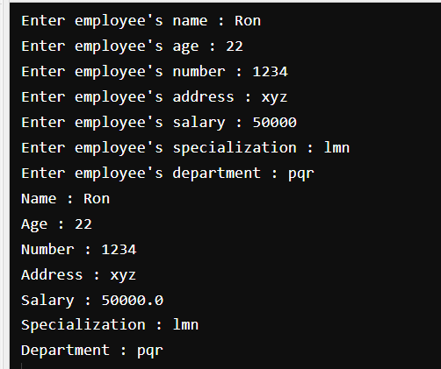

1. **Create a class named 'Rectangle' with two data members 'length' and 'breadth' and two methods to print the area and perimeter of the rectangle respectively. Its constructor having parameters for length and breadth is used to initialize length and breadth of the rectangle. Let class 'Square' inherit the 'Rectangle' class with its constructor having a parameter for its side (suppose s) calling the constructor of its parent class as 'super(s,s)'. Print the area and perimeter of a rectangle and a square.**

**→**

class Rectangle {

int length, breadth;

public Rectangle(int l, int b){

length = l;

breadth = b;

}

void Area(){

System.out.println("Area : " + (length * breadth));

}

void Perimeter(){

System.out.println("Perimeter : " + (2 * (length + breadth)));

}

}

public class Square extends Rectangle{

Square(int s){

super(s, s);

}

public static void main(String[] args) {

Square square = new Square(5);

Rectangle rectangle = new Rectangle(3, 5);

System.out.println("Square's area and perimeter : ");

square.Area();

square.Perimeter();

System.out.println("Rectangle's area and perimeter : ");

rectangle.Area();

rectangle.Perimeter();

}

}

**OUTPUT :**

